NOTICE

We consider that you’ve agreed to the dorm rules when you applied for the dormitory.
You will be dismissed if…
- your penalty points reach to 30 points.
- you stay with a non-resident or the opposite gender in your room.
- you drink, smoke, fight, steal, gamble, play with fire and do any other dangerous actions in dorm.
- you are uncooperative in preventing from diseases (ex. To refuse to wear a mask in COVID situation).

All new students are expected to fill out the check list form for dormitory access, measure and record your temperature on it and follow below personal hygiene practices to prevent COVID-19.

- Wash your hands with soap for 30seconds
or more under running water.
2. Cover your cough or sneeze with your sleeve (not your hands).
3. Wearing masks in public. It is a MUST when you are in public places.
4. Cancel or delay your gathering, eating out, travel
or hangouts.
5. Report to dormitory coordinator(031-219-2149/jhk1092@ajou.ac.kr/ 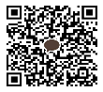-individuals who have
respiratory symptoms(cough, phlegm,difficulties on
breathing etc.) and pneumonia symptoms with fever.

6. Avoid physical contact and always keep 2 meters distance
(at least 1M).
7. Ventilate your space at least twice a day and disinfect regularly.

8. Keep in touch with family and friends while maintaining physical distancing.
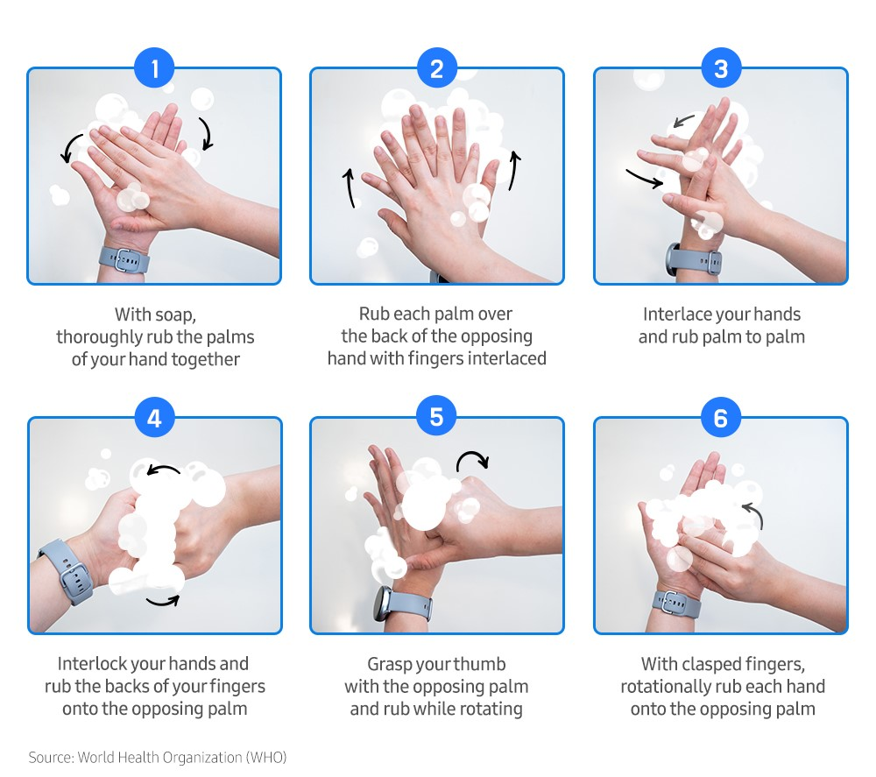
Dormitory Regulations
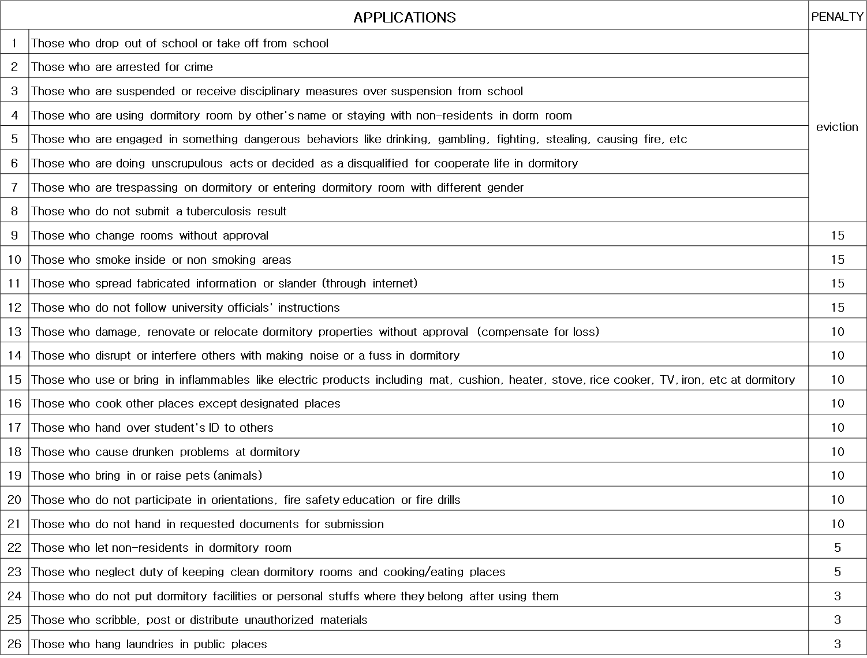
- Behavior that disrupts or interferes with the orderly functions in or around the on Campus Housing community is prohibited.

