2020-2 FALL SEMESTER DORMITORY APPLICATION AND REGISTRATION PROCEDURE
Students who do not currently reside in the dormitory may be restricted from applying for the dormitory, so make sure to check it at the office at Hwahong Hall 1F.
Currently, students who do not live in dormitories can only join if they have face-to-face classes.
*Log in->(change language into Eng.-it's bottom of the page)
->(New)Academic Affairs Information(학사서비스)->Application for Student living->Dormitory Application*
1. Schedule for 2020-2 semester
CLASSIFICATION | PERIODS | NOTE
Application Periods | AUG.13(THU)~AUG.17(MON) | http://edorm.ac.kr  Please come to office to check if your application has done successfully.
Registration Periods | AUG.20(THU)~AUG.21(FRI) | Please contact jhk1092@ajou.ac.kr or visit to Hwahong hall office to receive the invoice or transfer to Kookmin Bank (KB) 808490-29-000633 Ajou University Dormitory in your name.
2020-2 (fall) semester  Move-In-Day | AUG. 29 (SAT) | Please submit a tuberculosis certificate before entering the dormitory.
2020-2 (fall) semester  Move-Out-Day | DEC. 23 (WED) | Please submit a check-out note before moving out. If you leave your stuffs after Move-Out-Day, you should pay for the next dorm fee.

2. Dormitory Fees (for the year of 2020)
Regular Semester | HWAHONG HALL |  | INTERNATIONAL DORM
Regular Semester | 2-BED ROOM | 4-BED ROOM | 2-BED ROOM ONLY
Regular Semester | 944,000KRW | 640,000KRW | 1,234,000KRW
*In the case of the new international dormitory, a Korean student and an international student can be assigned together as roommates.
*If we don’t have any 4bed-room left to assign, we can assign you to a 2bed-room without your prior permission or you can be assigned to other dormitory buildings where Korean students are living if there will be available rooms.

Check!!!
You can get the bill if you come to Hwahong Hall 1F at coordinator’s office during the above registration periods.

3. Tuberculosis Test
Before moving in the dorm, all residents should submit the result of a Tuberculosis check (TB). The result sheet must show normal or abnormal of TB in English or Korean.
Without the result sheet, students cannot move in.
Tuberculosis check result should be updated every year. It is valid for one year.

4. Refund Policy
 | within 4 weeks | within 8 weeks | within 12 weeks | after 12 weeks
Payment | 100% | 75% | 50% | 25%
Refund | 75% | 50% | 25% | 0
a. If residents need to leave in the middle of the semester, residents should apply for refund request.
Without refund request, we have no responsibility to refund your dorm fee.
b. The dormitory fee will be refunded to the student according to the dormitory policy.
c. The criteria of refund policy are based on the move-in date given by the dormitory and not by the individual students' actual move-in date.
d. Residents who are expelled due to violation of dormitory rules and regulations will have NO REFUND
e. Summer or winter vacation residents have no refund even though early withdrawal from the dormitory.

-Notice-
Dormitory Coordinator for Foreign Students : Haekyung Jang (Kay)
E-mail: jhk1092@ajou.ac.kr Tel: +82-31-219-2149 Office: Hwahong Hall 1st floor
1. Due to limited accommodations, room arrangement cannot be guaranteed as your preference and your room can be changed even after being assigned if an unexpected situation occurs.
2. If you do not apply for the dormitory within the application period, the application cannot be acceptable.
3. If you don’t pay the bill by the due date, your application can be cancelled.
4. Every resident should submit a TB check result sheet (Tuberculosis) before moving in.
5. If you put your stuffs in dormitory without applying for it, they will be cleared out without any notice.
You are responsible for your own belongings. We cannot keep your stuffs. We cannot be held responsible for the damage or loss of your goods.
6. Dormitory offers bedding sets (blanket and bed sheet only) at the security office each dorm.
7. Please remember the move out day. After move out day, you must leave the dorm or you could pay the whole fee of the next dorm periods.
8. The dormitory application submission period for international students will be the same as local students -No application allowed after the deadline.
- Room Assignment Guidelines

A. Room assignment will be handled by the Office of Student Housing & Residence with full consideration of applicants’ requests.
B. The request period for room changes will be the first week of each semester.
C. Students who have sleep disorders (snoring, teeth grinding, etc.) serious enough to disturb roommates
cannot be accepted.
D. Students can choose from the two types of rooms: two-bed rooms and four-bed rooms.
Four bed rooms are so popular, so the Office of Student Housing & Residence may randomly assign therooms. If we don’t have any more 4bed-room left to assign, we will arrange you to 2bed-room randomly or you can be assigned to other dormitory buildings where Korean students are living if there will be available rooms.
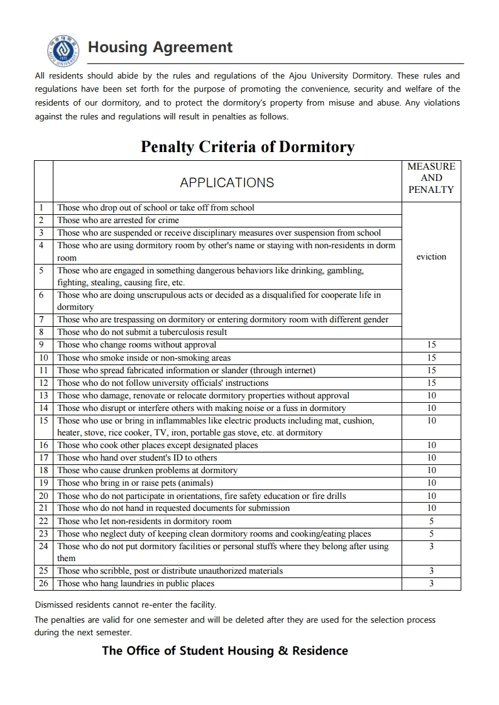
You'll be forced to leave the dormitory without refund if you get 30 penalty points.
If you leave the dormitory for something unsavory, you will never be able to join the dormitory again.

