소방 안전 교육 (Fire Safety Education) Step1.
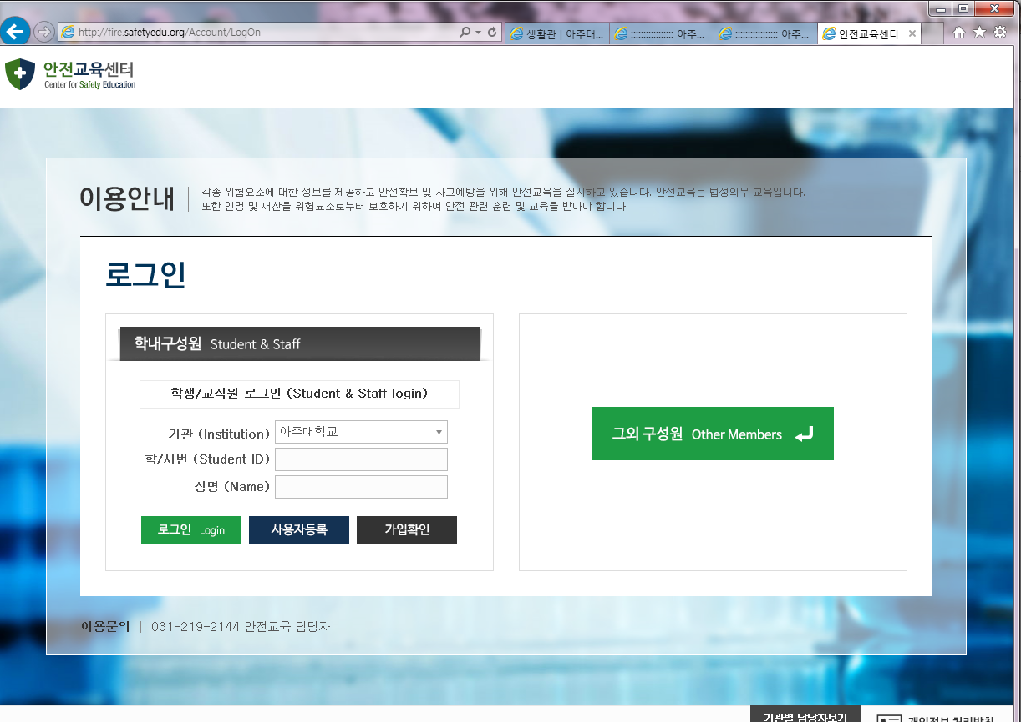
Student ID &
NAME

Step 2.
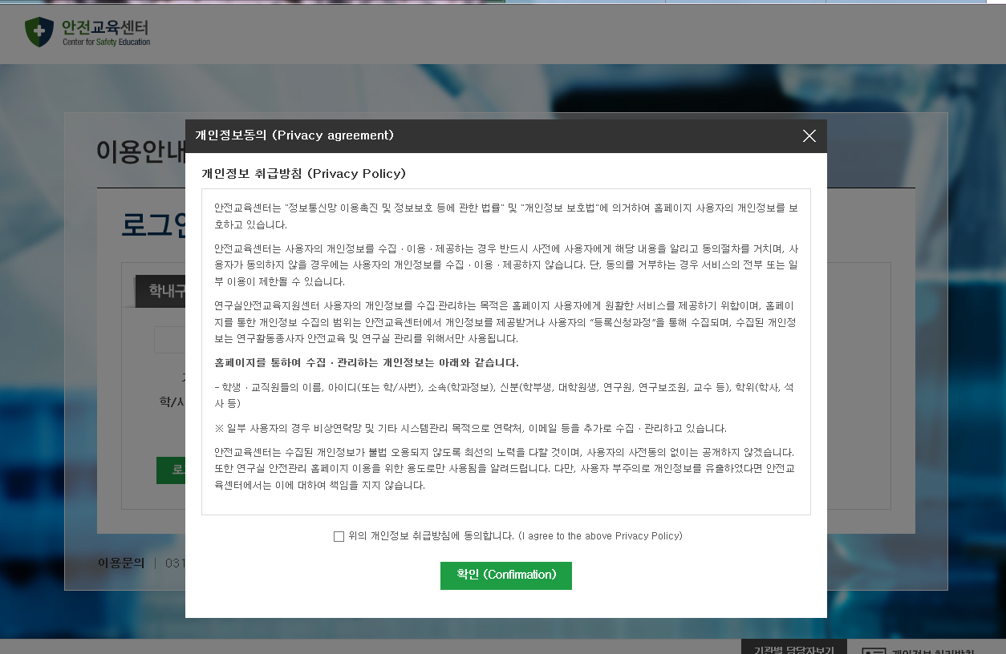
- Click agreement
2. Click confirmation

Step 3
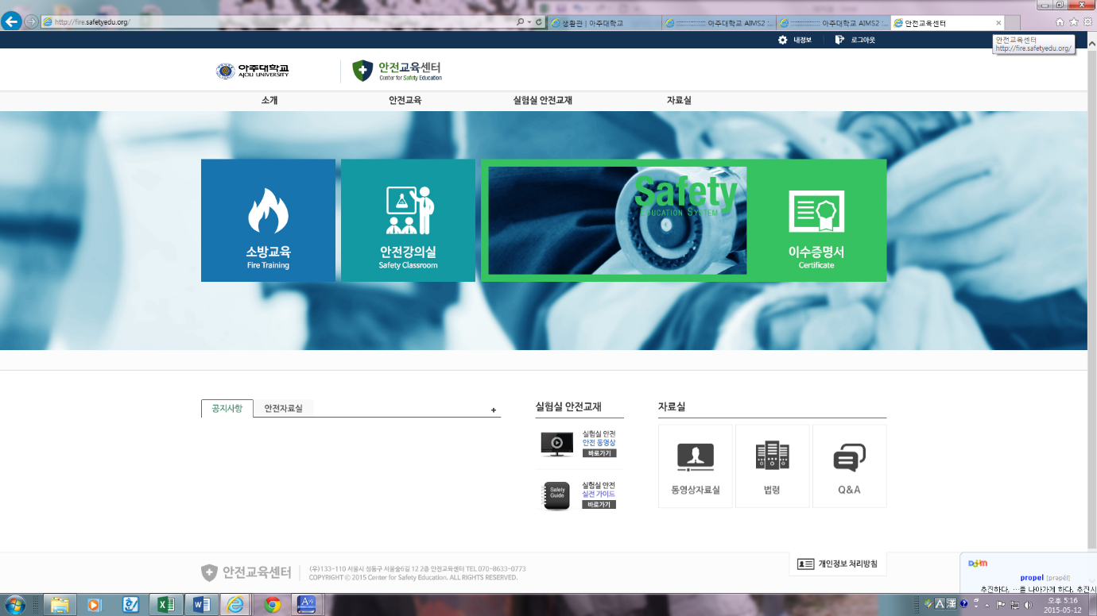
Click Fire Training

Step 4.
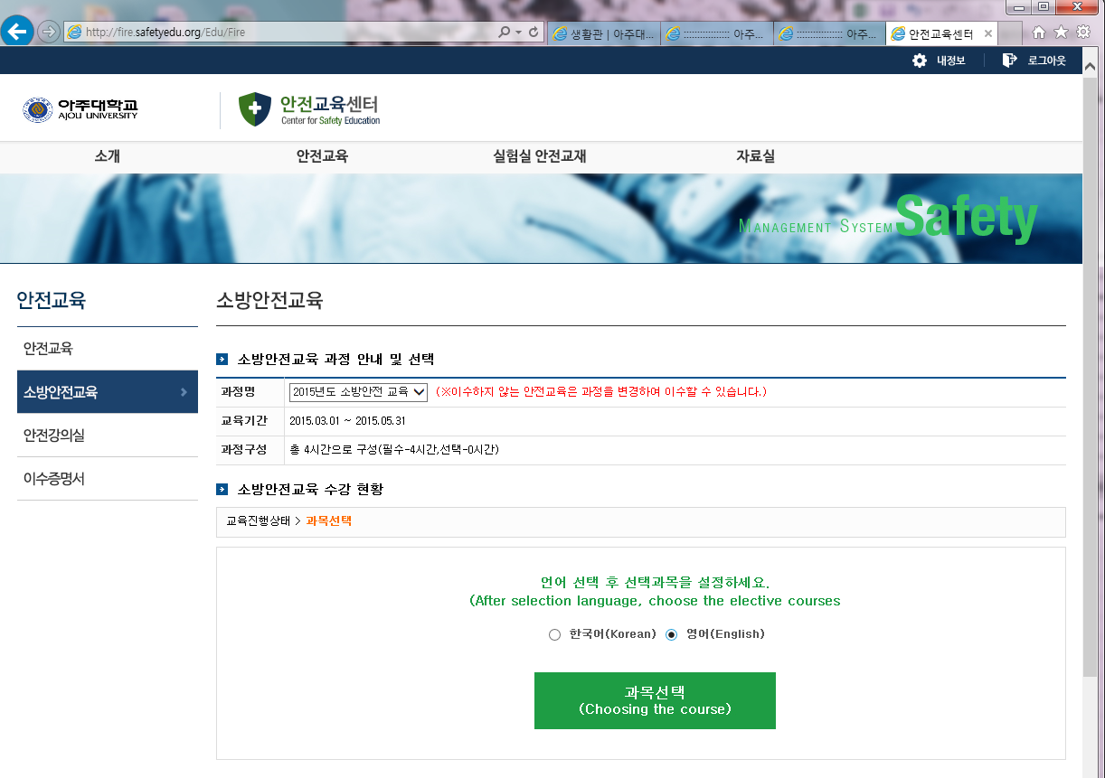
Choose the language &
The course

Step 5.
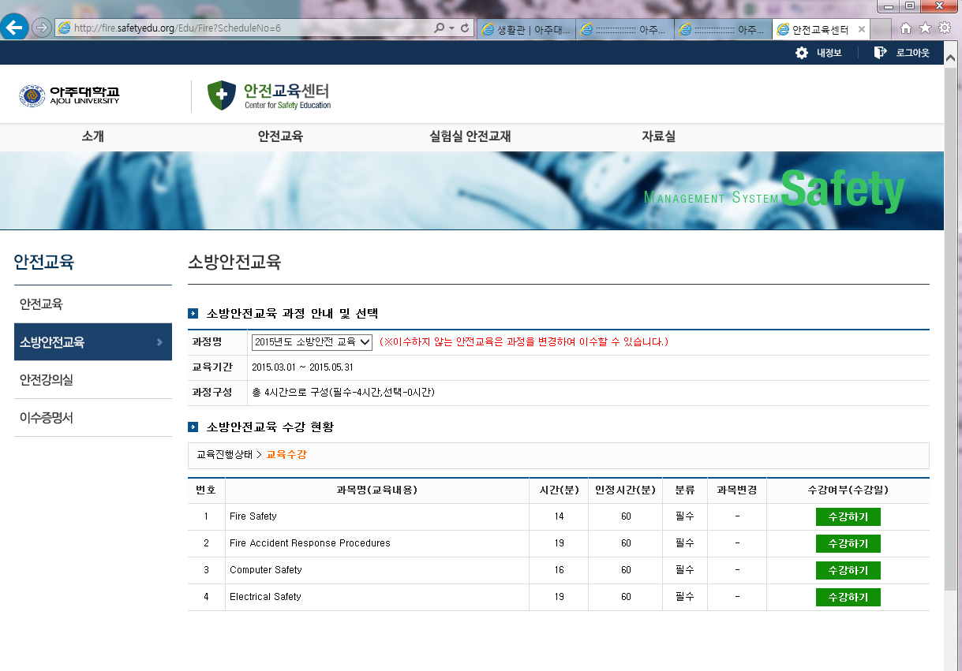
Now you can click 2section “수강하기” for the study.(2hours)
Now you need to click “평가하기”(Examination)

