소방 안전 교육 (Fire Safety Education) Step1.
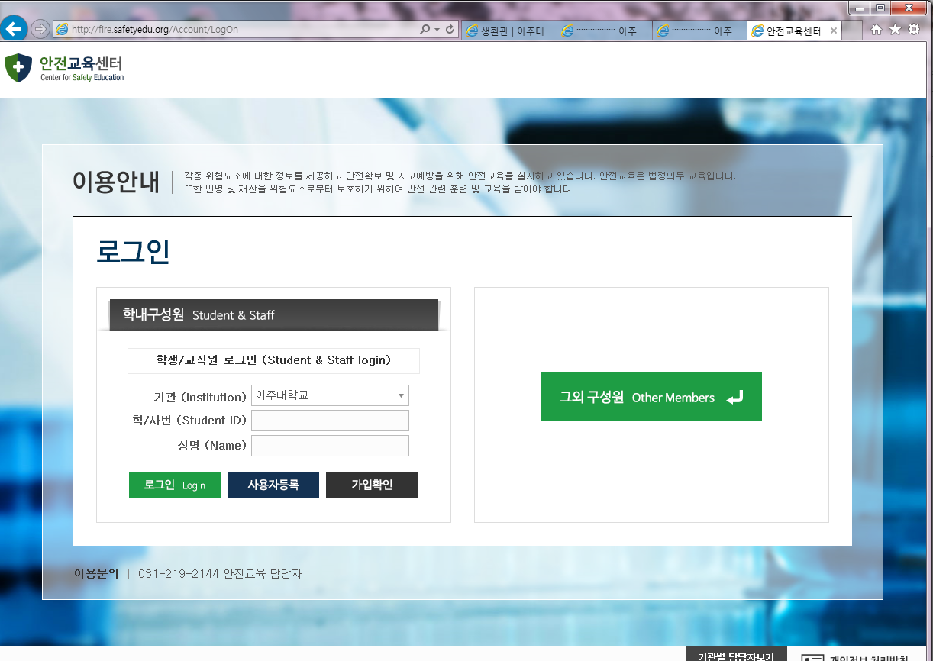
Student ID &
NAME

Step 2.
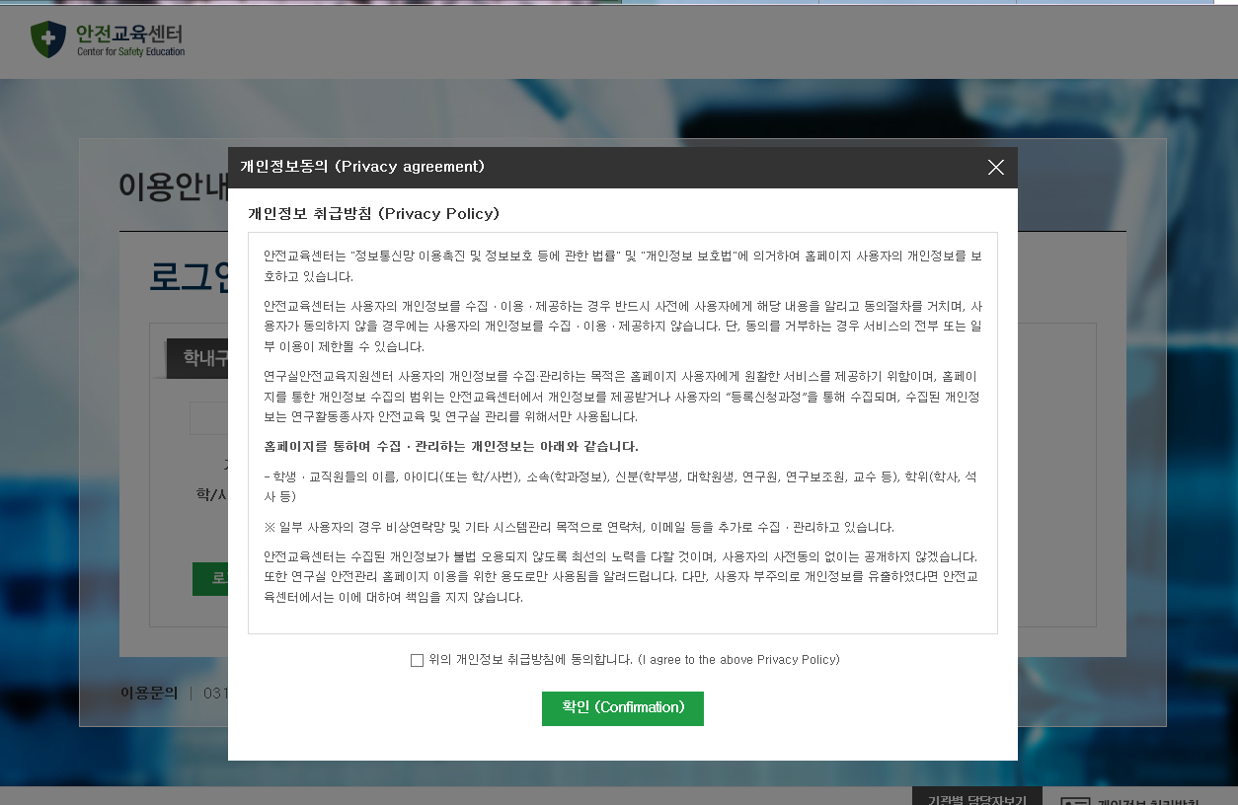
- Click agreement
2. Click confirmation

Step 3
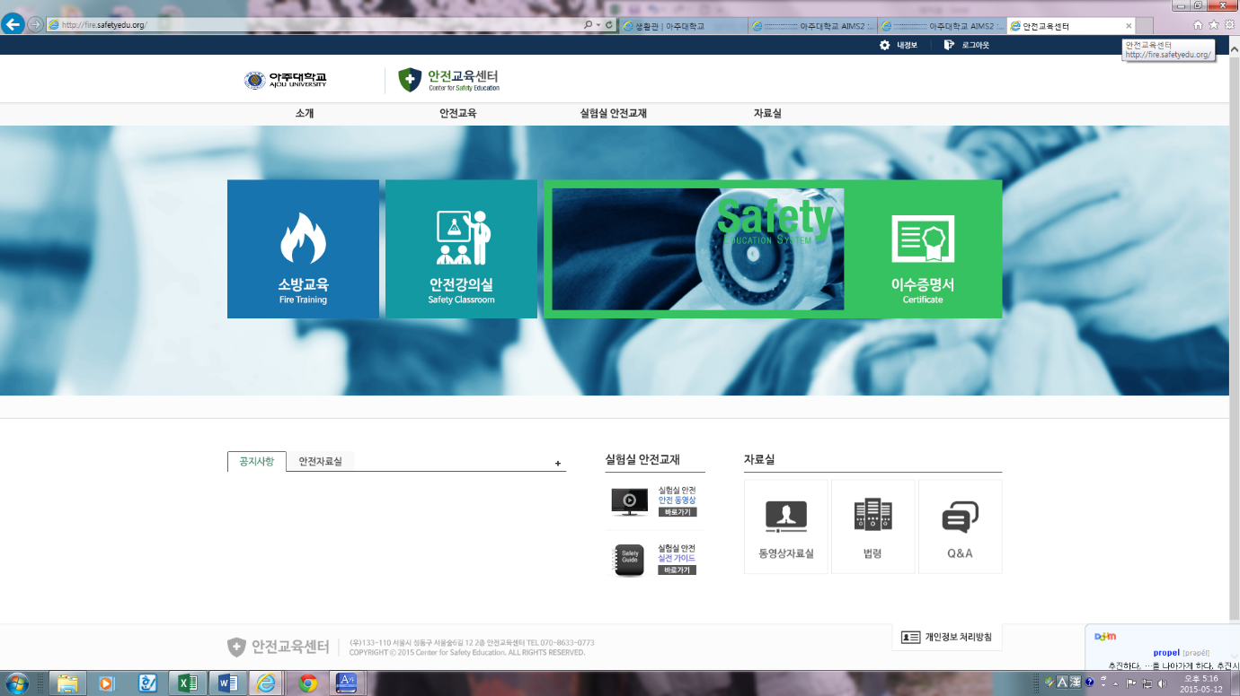
Click Fire Training

Step 4.
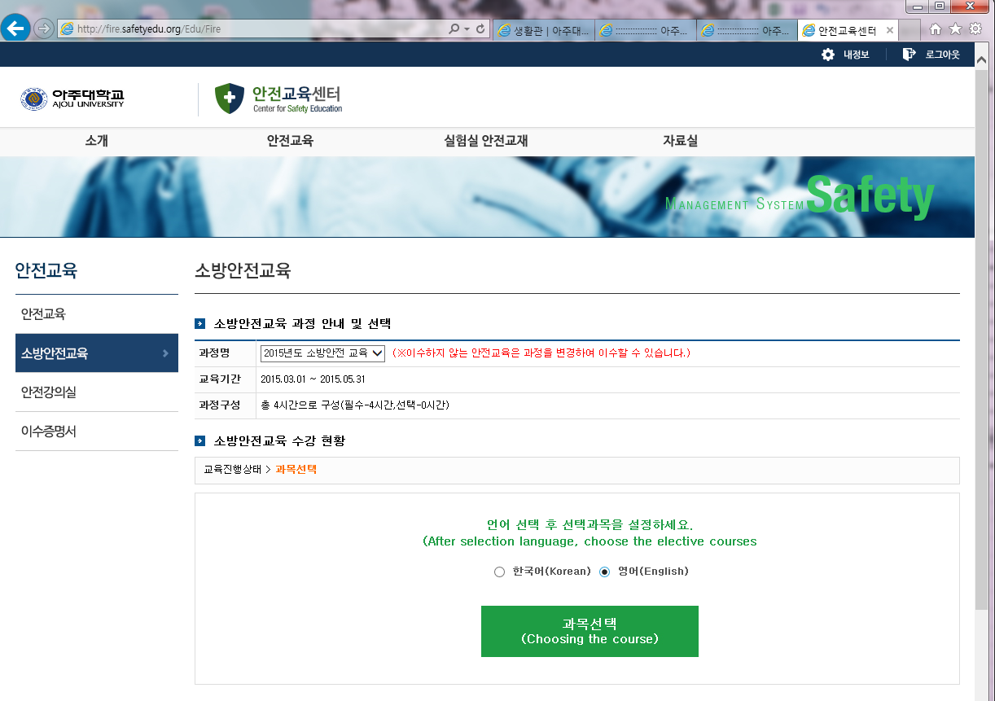
Choose the language &
The course

Step 5.
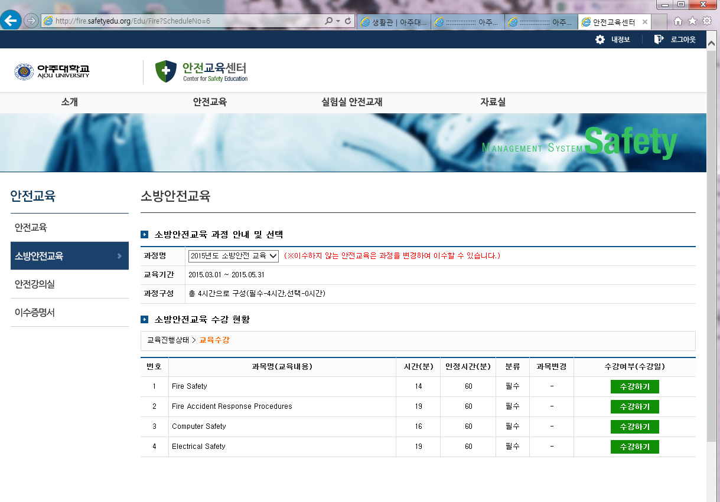
Now you can click 2section “수강하기” for the study.(2hours)
Now you need to click “평가하기”(Examination)

If you didn’t click the examination, we can not mark you as having completely finished the course.
If you don’t take Fire safety education you will get penalty of 10point as it is compulsory.

