<Zika virus>
Prevention
When traveling to countries where Zika virus or other viruses spread by mosquitoes are found, take the following steps:
- Wear long-sleeved shirts and long pants.
- Stay in places with air conditioning or that use window and door screens to keep mosquitoes outside.
- Sleep under a mosquito bed net if you are overseas or outside and are not able to protect yourself from mosquito bites.
- Use Environmental Protection Agency (EPA)-registered insect repellents. When used as directed, EPA-registered insect repellents are proven safe and effective, even for pregnant and breast-feeding women.
  - Always follow the product label instructions
  - Reapply insect repellent as directed.
  - Do not spray repellent on the skin under clothing.
  - If you are also using sunscreen, apply sunscreen before applying insect repellent.

Symptoms
- About 1 in 5 people infected with Zika virus become ill (i.e., develop Zika).
- The most common symptoms of Zika are fever, rash, joint pain, or conjunctivitis (red eyes). Other common symptoms include muscle pain and headache. The incubation period (the time from exposure to symptoms) for Zika virus disease is not known, but is likely to be a few days to a week.
- The illness is usually mild with symptoms lasting for several days to a week.
- People usually don’t get sick enough to go to the hospital, and they very rarely die of Zika.
- Zika virus usually remains in the blood of an infected person for about a week but it can be found longer in some people.
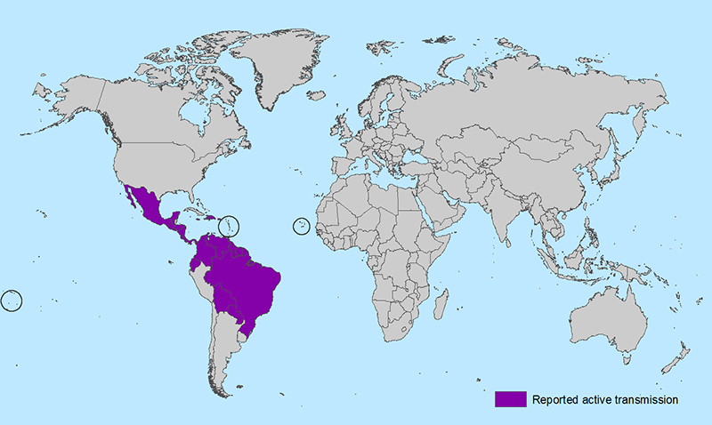
Active Zika Virus Transmission
Americas
- Barbados  - Bolivia  - Brazil  - Colombia  - Commonwealth of  Puerto Rico, US territory  - Costa Rica  - Curacao  - Dominican Republic  - Ecuador | - El Salvador  - French Guiana  - Guadeloupe  - Guatemala  - Guyana  - Haiti  - Honduras  - Jamaica  - Martinique | - Mexico  - Nicaragua  - Panama  - Paraguay  - Saint Martin  - Suriname  - U.S. Virgin Islands  - Venezuela

Oceania/Pacific Islands
- American Samoa
- Samoa
- Tonga

Africa
- Cape Verde

