Hi, everyone!

We have got WiFi now. I will show how to connect with it.

Login to AJOU portal site first then do the following steps.

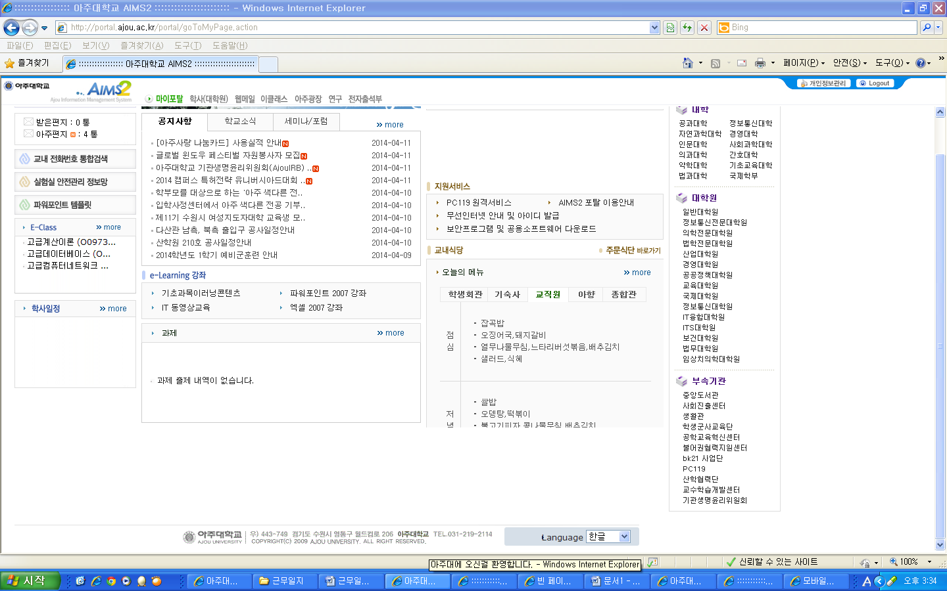
Press this link
무선인터넷 안내 및 아이디 발급

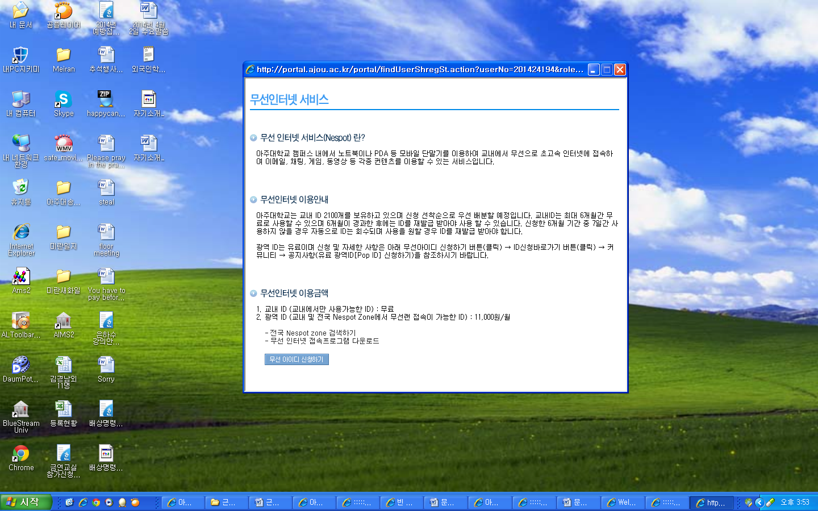
Click this link
무선 아이디 신청하기

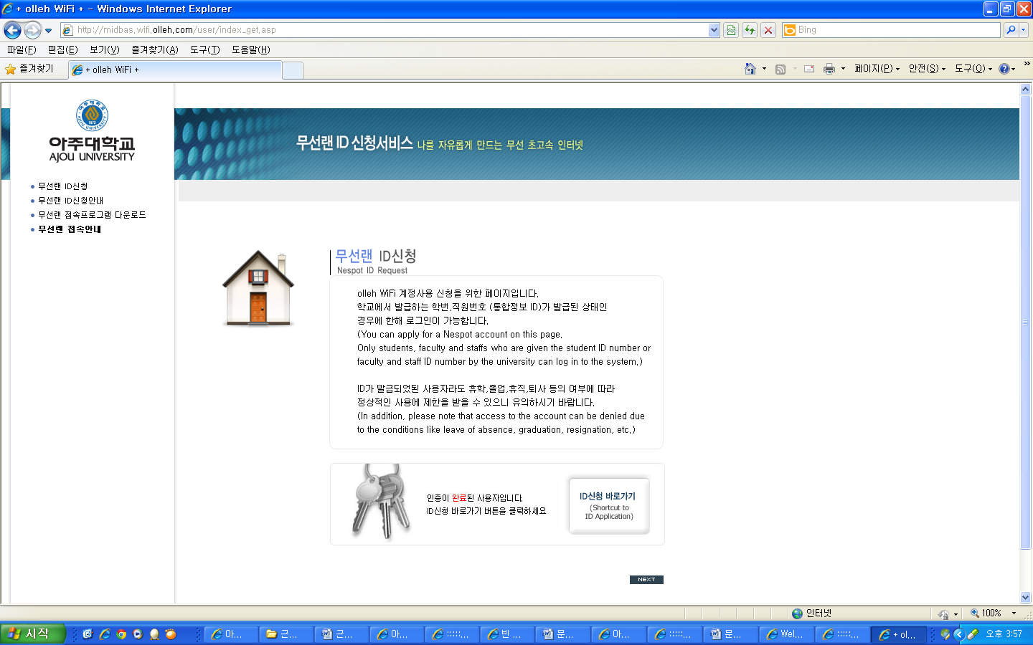

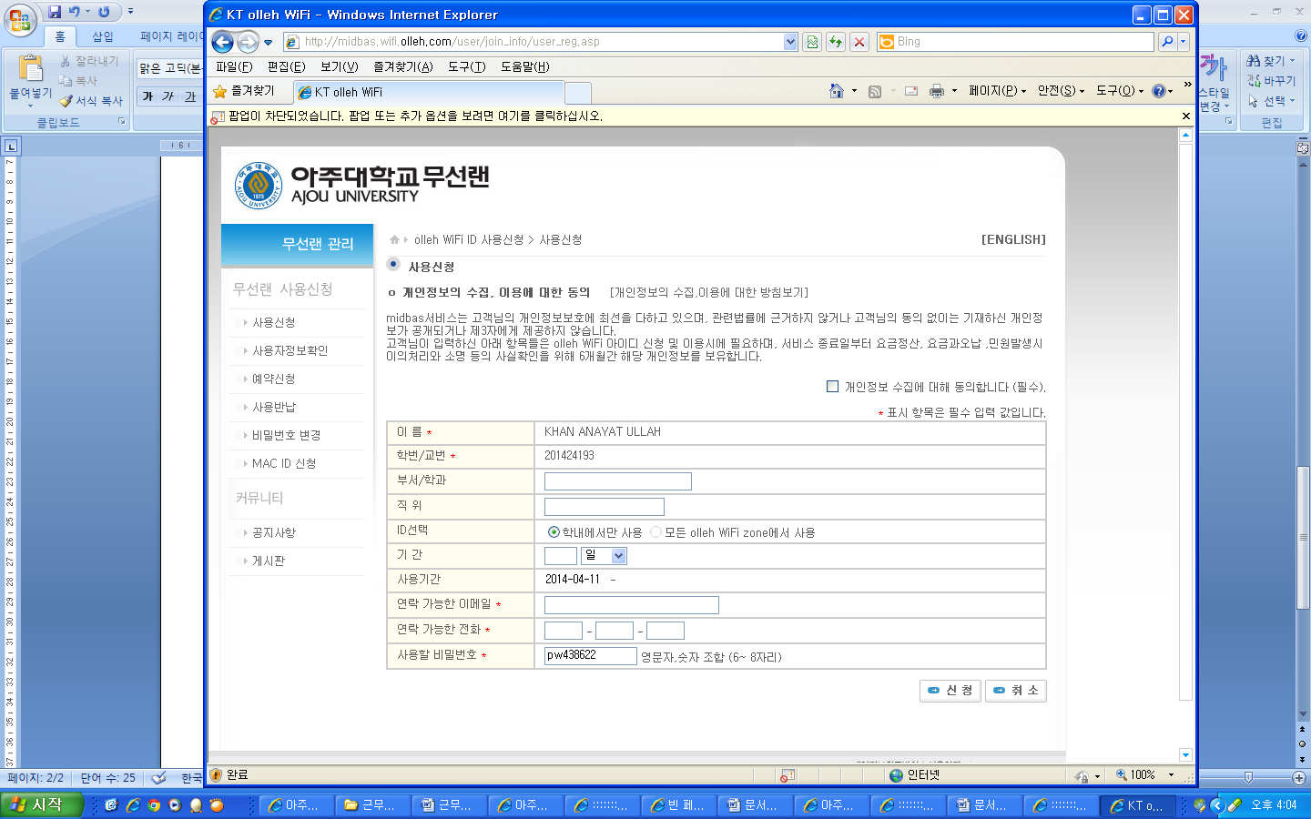

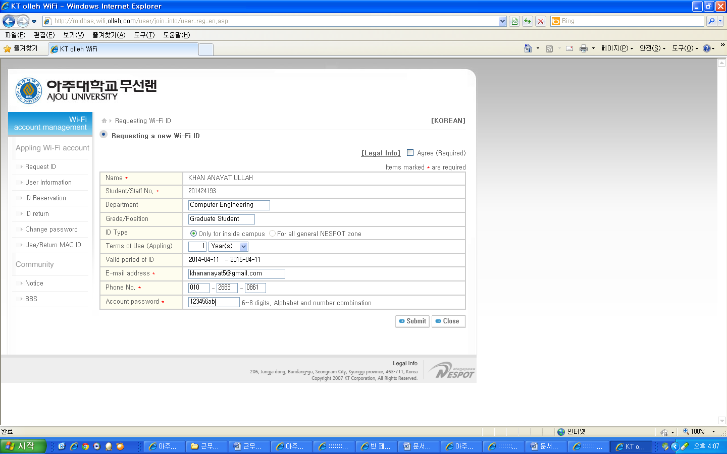
ID Type: Choose (Only for inside campus)
Term of usage (Appling): 1 Year(s)
Account password: This will be your password, you can change your password here.
Check Agree checkbox at the right top side.

- After register you will be given key(8 digit number) click “닫기”
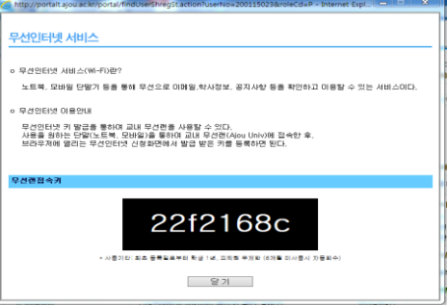
Click here

- Search Wi-Fi with your mobile device or computer then connect with “Ajou Univ” among the subsystem identification.
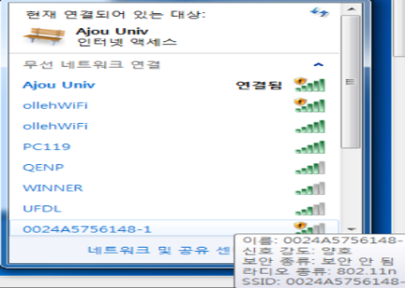

- When you open the internet browser the Wi-Fi application will be pop up automatically then click green box(Wi-Fi application:무선인터넷 사용신청)
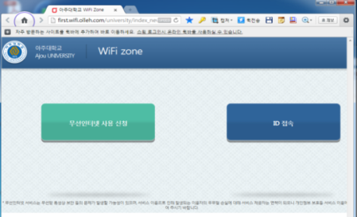

Click

- Click blue box(apply: 신청) after entering your key you are given
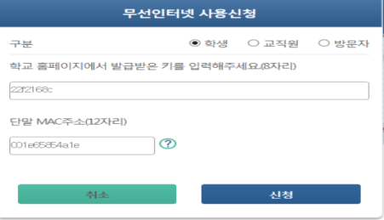

Enter your key

Click
- After complete internet application then click green box. Now you are able to use internet.

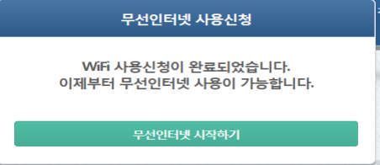
Click

